**Virus Spreading Model** **Maidi Xu 20063089**

**Research Question**

This model simulates the situation of limited medical equipment (hospital) resources in today's virus-running case, assigns a certain number of human beings in an area, and observes their macroscopic performance in the time and spatial span.

Under the premise of changing the characteristics of various viruses, how will the virus affect the human community? What will virus factors seriously affect the development of human societies? And when the features of the virus are maintained within a specific range, can the human community develop stably and coexist with the virus? The above hypothesis will be answered within the model.

**ODD Description**

1. **Purpose and Patterns**

This model addresses changes in human communities in the context of a virus. These viruses are initially carried by several individuals and spread based on the characteristics of the virus. When changing the variables of virus characteristics, the human community's infection rate and immunization rate can be investigated. With limited medical resources, the human society's infection rate and immunization rate will be composed of those viral characteristics in any combinations; what measures should the human community take when faced with viruses with different features?

This model can also investigate when individuals self-isolate after infection (unable to infect surrounding individuals) or when vaccines are added at a particular node of ticks to change the infection rate or severe disease rate caused by the vaccine.

1. **Entities, State Variables & Scales**

The agent of the model is carriers, and the variables are mainly whether it is sick, whether it is severe, and it's corresponding sick/severe time. There are variables such as the agents' age, the destination (if severe, a hospital visit is required), and the remaining immunization time. The map will randomly generate four white patches, which represent the spatial location of the hospital.

The entire model consists of a 17*17 grid, which the model can use to simulate a small community or a closed area. At the start of the model, 5 per cent of individuals will have the virus, which is sick.

Each tick represents a week in this model, so in the subsequent data analysis, we will run the model for 520 weeks, which is ten years.

1. **Process Overview & Scheduling**

**Infect:** Initially, 5 per cent of the virus carriers had mild symptoms. These mildly symptomatic individuals will infect neighbourhoods based on the [infectiousness] of the virus.

**Recover-or-die:** According to the virus characteristic [duration], the individual will begin to self-recover within a certain period, and self-recovery is also determined by the virus characteristic [chance-recovery]. If recovered, the individual will receive antibody immunity for 26 weeks which is half a year. For those individuals who cannot recover by themselves, they will turn from mild to severe, and the status of the agent will become severe=TRUE.

**Go to Hospital (severe move):** When a severe case occurs, the individual randomly selects a hospital as the destination and moves according to the closest strategy. In the process of moving, it will also probabilistically infect the individuals in the path, and when the moving time reaches 15 ticks and still does not reach the destination, it will die.

**Treat:** The treatment condition will bring two results: when the individual is within the cure rate, hospitals will cure individuals and be immune (again, 26 weeks or half a year). 2 is that when the individual is not within the cure rate, will die. To achieve therapeutic conditions, the prerequisite is that the severe individual needs to reach any of the white patches (which are hospitals). During treatment, the individual will stop moving and remain in the hospital for 15 days, about 2 weeks.

**Get older:** The age of all individuals increased with ticks. Everyone starts out with a random lifespan. The maximum life expectancy for natural death is 70 years.

1. **Design Concepts**

*Basic principles:* In the context of limited medical resources, the spatial and temporal representation and distribution of human communities in the face of viruses with different characteristic variables.

*Emergence:* This model distinguishes between severe and mild carriers and adds the decision after suffering from severe and mild disease like severe move and recover itself. It is expected to add the characteristics of the vaccine over time in future.

*Objectives:* The objectives of carriers are to stay healthy. Self-recovery in mild cases, and hospital treatment in severe cases.

*Learning:* The carriers’ behaviours are not based on expected future state and do not change; no learning or prediction are represented.

*Sensing:* Carriers are assumed do not know the information of others.

*Interaction:* The main interaction is whether the carriers will spread the virus to the surrounding people. This is based on the infection rate variable of the virus. And some carriers will become severe if they fail to recover themselves. Severe cases need to be moved to the hospital for treatment.

*Stochasticity:* Stochastic functions are used to initialize carriers’ locations, age, lifespan, sick or not, and to set the location of hospitals during the simulation. Whether a single carrier interaction with other carriers is a stochastic function of its infectiousness.

*Collectives:* Collectives are not represented. Each individual has a social network of other individuals that it treats as social peers and potential partners, but these network have no behaviours or characteristics of their own.

*Observation:* The graph on the left-hand side of the map corresponds to the overall number of people, the number of people with mild symptoms, people with severe disease, the number of people with antibodies, and the number of healthy people without antibodies. The graph on the right-hand side represents the proportion of infection and the ratio of antibodies over time.

1. **Initialisation**

The initial number of people is set at 0-800 people, default is 500 people. 5% of people will carry the virus. 4 hospitals will be randomly generated on the map. infectiousness, chance-recover and cure rate from 0-100%. Duration can be set between 0-100nweeks, default is 10 weeks.

1. **Input Data**

No time-series inputs are used.

1. **Submodels**

**Infect:**

Suppose the agent's state is non-sick, non-immune, non-severe, and the randomly generated parameter is lower than infectiousness. In that case, the virus will be infected, and the agent will become mild sick.

**Recover and die:**

Suppose the agent is in a mild sick state and the time of being sick exceeds the duration of the virus characteristic, and the random parameter of the agent is less than the chance of recovery. In that case, it will become an agent with immune if it is greater than the chance of recovery, the state of the agent changes to severe=true.

**Severe Move:**

The three processes are [set-destination], [goto-destination], and [check-reached-destination] in the severe move. When the agent is in a severe state, you need to set a random hospital as the destination if there is no destination. If there is a destination, face the destination and go. And continue to check whether the agents are in destination of the process. If true, [stay].

**Treat:**

The prerequisite process of [treat] is [stay]. In [stay], the agent needs to stop for 15 ticks in place. When count-down=0, [treat] will be run. In [treat], if the random parameter of the agent is less than the cure-rate, it will generate immune; if it is greater than the cure-rate, the agent will die.

**Methodology**

The model uses BehaviorSpace for data sorting and analysis. Variables that can be changed are duration, infectivity, number of people, the chance of recovery and cure rate. Using the control-variable method, changing only infectivity and number of people, the output of infection rates after ten years was analysed for the population and virus infectivity pairs. And closer to a virus in real life: Omicron; other variables will be references. In addition, the relationship between population and self-recovery will be analysed and output in the form of a matrix. They were used to analyse the relationship between infection rates in the population and self-recovery after ten years.

**Results**

The graph above shows the infection rate after ten years when population and infectiousness vary. As the initial population increases, the higher the infectiousness, the higher the final infection rate, indicating that the virus has not been defeated. It can be found that population size plays a more critical role in the final infection rate than infectiousness. When the population remains at 600, even if the infectiousness is low, there is still an infection rate; when the population is between 250 and 350, even if the infectiousness reaches 40-50%, the final infection rate tends to be 0.

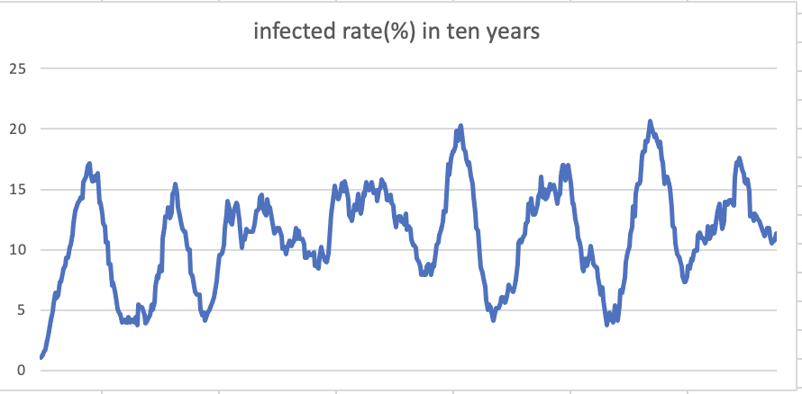

The above figure selects the median infection rate: infectiousness= 50 and population= 450. In ten years, it can be found that the infection rate peaks around 30 weeks after the outbreak of the virus and rapidly decreases in around the next 30 weeks to the lowest point. The reason is that the increase in antibodies leads to a decrease in the infection rate, and when the antibodies disappear after every half a year, it will cause a new peak in the infection rate.

**Conclusion**

Overall, the model introduces the possibility that the virus cannot be eliminated when the population size and the characteristics of the virus are changed with a limited medical base. Based on data analysis, this paper found that population density played a crucial role in determining the final infection rate in the model. While other factors can cause infection rates to rise or fall, they are not that important.